

Fork and Exec
The fork system call in Unix creates a new process. The new process inherits various properties from its parent (Environmental variables, File descriptors, etc - see the manual page for details). After a successful fork call, two copies of the original code will be running. In the original process (the parent) the return value of fork will be the process ID of the child. In the new child process the return value of fork will be 0. Here's a simple example where the child sleeps for 2 seconds while the parent waits for the child process to exit. Note how the return value of fork is used to control which code is run by the parent and which by the child.
 | 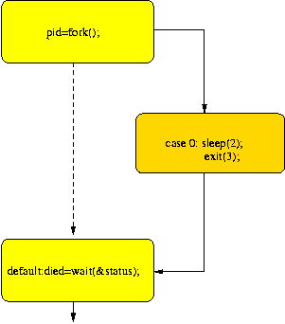
  #include <unistd.h>
  #include <sys/wait.h>
  #include <iostream>
  using namespace std;
  int main(){
  pid_t pid;
  int status, died;
  switch(pid=fork()){
  case -1: cout << "can't fork\n";
  exit(-1);
  case 0 : sleep(2); // this is the code the child runs
  exit(3);
  default: died= wait(&status); // this is the code the parent runs
  }
  }
In the following annotated example the parent process queries the child process in more detail, determining whether the child exited normally or not. To make things interesting the parent kills the child process if the latter's PID is odd, so if you run the program a few times expect behaviour to vary.
#include <unistd.h>
#include <sys/wait.h>
#include <signal.h>
#include <iostream>
using namespace std;

int main(){
pid_t pid;
int status, died;
switch(pid=fork()){
case -1: cout << "can't fork\n";
exit(-1);
case 0 : cout << " I'm the child of PID " << getppid() << ".\n";
cout << " My PID is " << getpid() << endl;
sleep(2);
exit(3);
default: cout << "I'm the parent.\n";
cout << "My PID is " << getpid() << endl;
// kill the child in 50% of runs
if (pid & 1)
kill(pid,SIGKILL);
died= wait(&status);
if(WIFEXITED(status))
cout << "The child, pid=" << pid << ", has returned "
<< WEXITSTATUS(status) << endl;
else
cout << "The child process was sent a "
<< WTERMSIG(status) << " signal\n";
}
}
In the examples above, the new process is running the same program as the parent (though it's running different parts of it). Often however, you want the new process to run a new program. When, for example, you type "date" on the unix command line, the command line interpreter (the so-called "shell") forks so that momentarily 2 shells are running, then the code in the child process is replaced by the code of the "date" program by using one of the family of exec system calls. Here's a simple example of how it's done.
#include <unistd.h>
#include <sys/wait.h>
#include <iostream>
using namespace std;

int main(){
pid_t pid;
int status, died;
switch(pid=fork()){
case -1: cout << "can't fork\n";
exit(-1);
case 0 : execl("/usr/bin/date","date",0); // this is the code the child runs
default: died= wait(&status); // this is the code the parent runs
}
}
The child process can communicate some information to its parent via the argument to exit, but this is rather restrictive. Richer communication is possible if one takes advantage of the fact that the child and parent share file descriptors. The popen() command is the tidiest way to do this. The following code uses a more low-level method.
The pipe() command creates a pipe, returning two file descriptors; the 1st opened for reading from the pipe and the 2nd opened for writing to it. Both the parent and child process initially have access to both ends of the pipe. The code below closes the ends it doesn't need.
#include <unistd.h>
#include <sys/wait.h>
#include <iostream>
#include <sys/types.h>
using namespace std;
int main(){
char str[1024], *cp;
int pipefd[2];
pid_t pid;
int status, died;

pipe (pipefd);
switch(pid=fork()){
case -1: cout << "can't fork\n";
exit(-1);

case 0 : // this is the code the child runs
close(1); // close stdout
// pipefd[1] is for writing to the pipe. We want the output
// that used to go to the standard output (file descriptor 1)
// to be written to the pipe. The following command does this,
// creating a new file descripter 1 (the lowest available)
// that writes where pipefd[1] goes.
dup (pipefd[1]); // points pipefd at file descriptor
// the child isn't going to read from the pipe, so
// pipefd[0] can be closed
close (pipefd[0]);
execl ("/usr/bin/date","date",0);
default: // this is the code the parent runs

close(0); // close stdin
// Set file descriptor 0 (stdin) to read from the pipe
dup (pipefd[0]);
// the parent isn't going to write to the pipe
close (pipefd[1]);
// Now read from the pipe
cin.getline(str, 1023);
cout << "The date is " << str << endl;
died= wait(&status);
}
}
In all these examples the parent process waits for the child to exit. If the parent doesn't wait, but exits before the child process does, then the child is adopted by another process (usually the one with PID 1). After the child exits (but before it's waited for) it becomes a "zombie". If it's never waited for (because the parent process is hung, for example) it remains a zombie. In more recent Unix versions, the kernel releases these processes, but sometimes they can only be removed from the list of processes by rebooting the machine. Though in small numbers they're harmless enough, avoiding them is a very good idea. Particularly if a process has many children, it's worth using waitpid() rather than wait(), so that the code waits for the right process. Some versions of Unix have wait2(), wait3() and wait4() variants which may be useful.

Double fork
One way to create a new process that is more isolated from the parent is to do the following
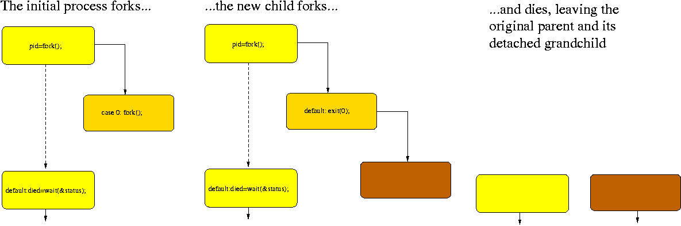
The original process doesn't have to wait around for the new process to die, and doesn't need to worry when it does.

Notes
- Note that on some systems vfork() might be faster than fork()
- "Advanced Programming in the UNIX Environment", W.Richard Stevens, Addison-Wesley ISBN 0-201-56317-7

[Unix signals and forking] [Unix] [C++] [Help]

Updated March 2002
tpl@eng.cam.ac.uk

Unix: fork() and wait()
As an example of process creation, we shall consider UNIX. The following example program is written in C++ and makes use of the standard library function fork(). The syntax of fork is
returncode = fork();
When this instruction is executed, the process concerned splits into two and both continue to execute independently from after the fork intruction. If fork is successful, it returns 0 to the child process and the process identifier or pid of the child process to the parent. It, for some reason, a new process cannot be created it returns a value of -1 to the parent.
The following example does not check for errors if fork fails.
//**************************************************************
//*
//* A brief demo of the UNIX process duplicator fork().
//*
//* g++ unix.C to compile this.
//*
//**************************************************************

#include <iostream.h>

extern "C" void sleep();
extern "C" int fork();
extern "C" int getpid();
extern "C" void wait();
extern "C" void exit();

void ChildProcess();

//***************************************************************

main ()

{ int pid, cid;

pid = getpid();

cout << "Fork demo! I am the parent (pid = " << pid << ")\n";

if (! fork())
{
cid = getpid();
cout << "I am the child (cid=" << cid << ") of (pid = " << pid << ")\n";
ChildProcess();
exit(0);
}

cout << "Parent waiting here for the child...\n";
wait(NULL);

cout << "Child finished, parent quitting too!\n";
}

//**************************************************************

void ChildProcess()

{ int i;

for (i = 0; i < 10; i++)
{
cout << i << "..\n";
sleep(1);
}
}
Here is the output from the program in a test run. Note that the parent and child processes share the same output stream, so we see how they are synchronised from the order in which the output is mixed.
Fork demo! I am the parent (pid = 2196)
I am the child (cid=2197) of (pid = 2196)
0..
Parent waiting here for the child...
1..
2..
3..
4..
5..
6..
7..
8..
9..
Child finished, parent quitting too!
Note that the child has time to execute its first instruction before the parent has time to call wait(), so the zero appears before the message from the parent. When the child goes to sleep for one second, the parent catches up.

YNOPSIS
#include <unistd.h>
pid_t fork(void);

DESCRIPTION
The fork() function creates a new process. The new process (the child process) is an exact copy of the calling process (the parent process). The child process inherits the following attributes from the parent process:
- Real and effective user and group IDs
- Environment settings
- Signal handling settings
- Attached shared memory segments
- Memory mapped segments
- Process group ID
- Current working directory
- File mode creation mask
- Controlling terminal
- nice value
The child process differs from the parent process in the following ways:
- The child process has a unique process ID, which also does not match any active process group ID.
- The child process has a different parent process ID (that is, the process ID of the process that called fork()).
- The child process has its own copy of the parent's file descriptors Each of the child's file descriptors refers to the same open file structures as the file descriptor of the parent.
- The child process has its own copy of the parent's open directory streams.
- The child process' process execution times (as returned by times()) are set to zero.
- Pending alarms are cleared for the child.
- All semaphore adjustment values are cleared.
- File locks set by the parent process are not inherited by the child process.
- The set of signals pending for the child process is cleared.
- Interval timers are reset.
The new process has a single thread. If a multi-threaded process calls fork(), the new process contains a replica of the calling thread and its entire address space, including the states of mutexes and other resources. Consequently, to avoid errors, the child process may only execute async-signal safe operations until such time as one of the exec() functions is called. Fork handlers may be established using the pthread_atfork() function to maintain application invariants across fork() calls.

PARAMETERS
None.

RETURN VALUES
If successful, fork() returns 0 in the child process, and returns the process ID of the child process to the parent process. On failure, it returns -1 and sets errno to one of the following values:
EAGAIN
The system lacked the necessary resources to create another process, or the system-imposed limit on the total number of processes under execution system-wide would be exceeded.
The process calling fork() is not a NuTCRACKER Platform process.
ENOSYS
fork() was called inside the child of a vfork() operation.

Also see this
alarm(), execl(), execle(), execlp(), execlpe(), execv(), execve(), execvp(), execvpe(),signal(),vfork()

